**Experiment No. 4**

**Title:**

Provisioning and Scaling a Website Using Codenvy

**Objective:**

To demonstrate the provisioning and scaling of a website using Codenvy, an integrated development environment (IDE) for cloud-based projects.

**Tools used:**

Codenvy, Internet, Web Browser

**Prerequisite:**

Basic understanding of website development, infrastructure provisioning, and scaling concepts.

**Theory:**

Codenvy is a cloud-based development environment that allows collaborative coding, debugging, and deployment of applications. It provides a platform for teams to work together on projects, offering support for various programming languages and integration with version control systems like Git. With Codenvy, users can develop and deploy applications without worrying about setting up individual development environments.

**Steps to Setup and Demonstrate Provisioning and Scaling:**

To access Codenvy, visit Codenvy's website [www.codenvy.com](http://www.codenvey.com) But it is taken over by

www.developers.redhat.com/products/openshift-dev-spaces/overview/

Once logged in, you can create a workspace and perform the steps mentioned above within the Codenvy interface.

**Step 1: Sign in to Codenvy**

- Access the Codenvy platform using your credentials via a web browser.

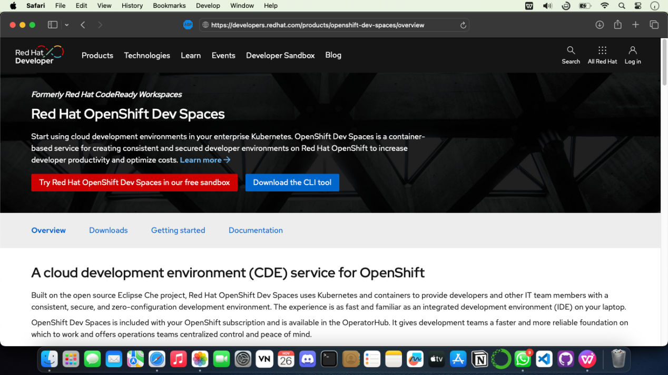

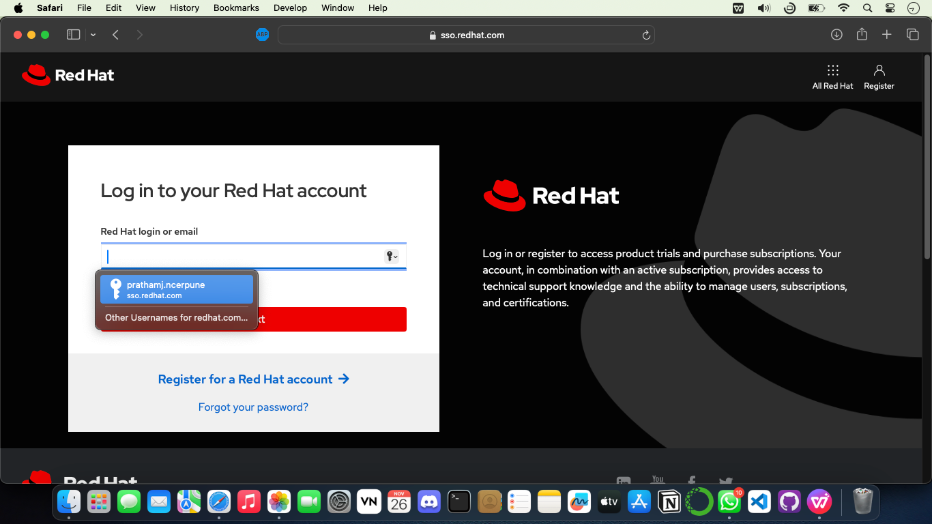

**Step 2: Create a New Workspace**

- Create a new workspace within Codenvy for your website project.

- Select the appropriate stack/environment based on your website's technology stack(ex-php,etc)

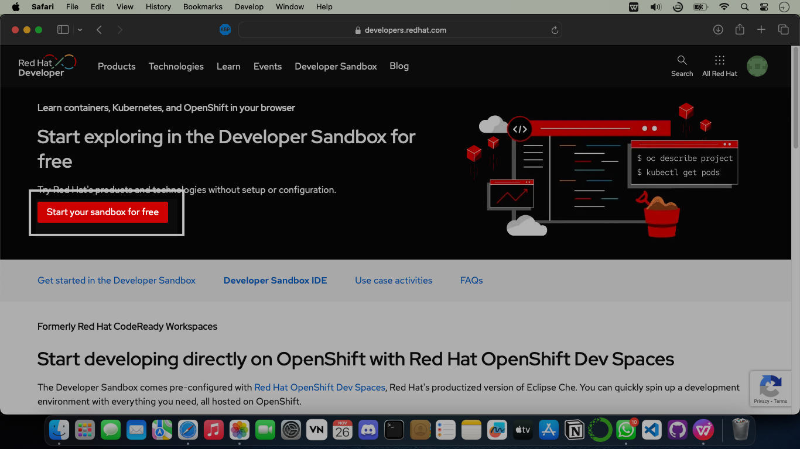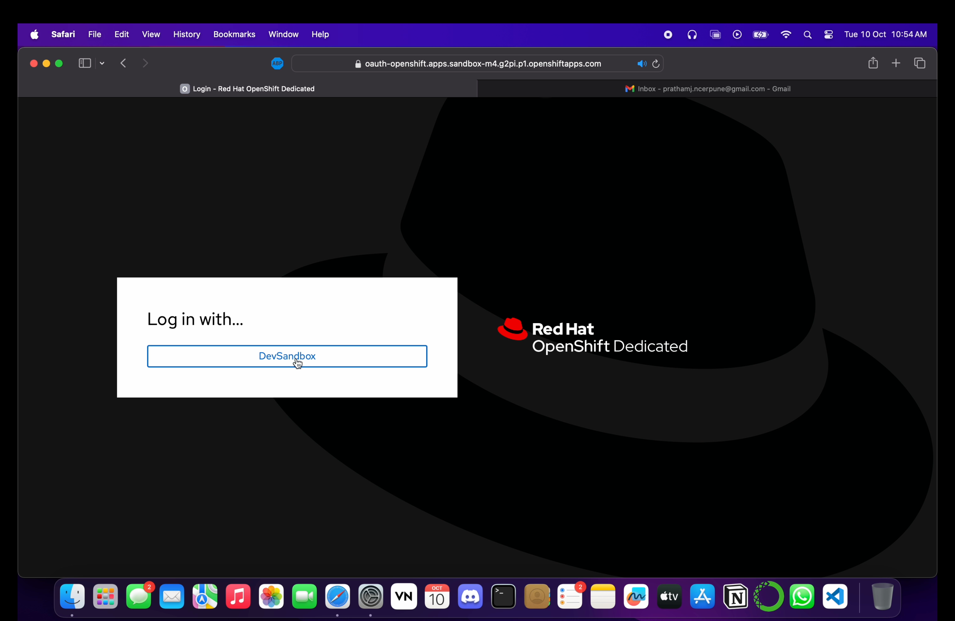 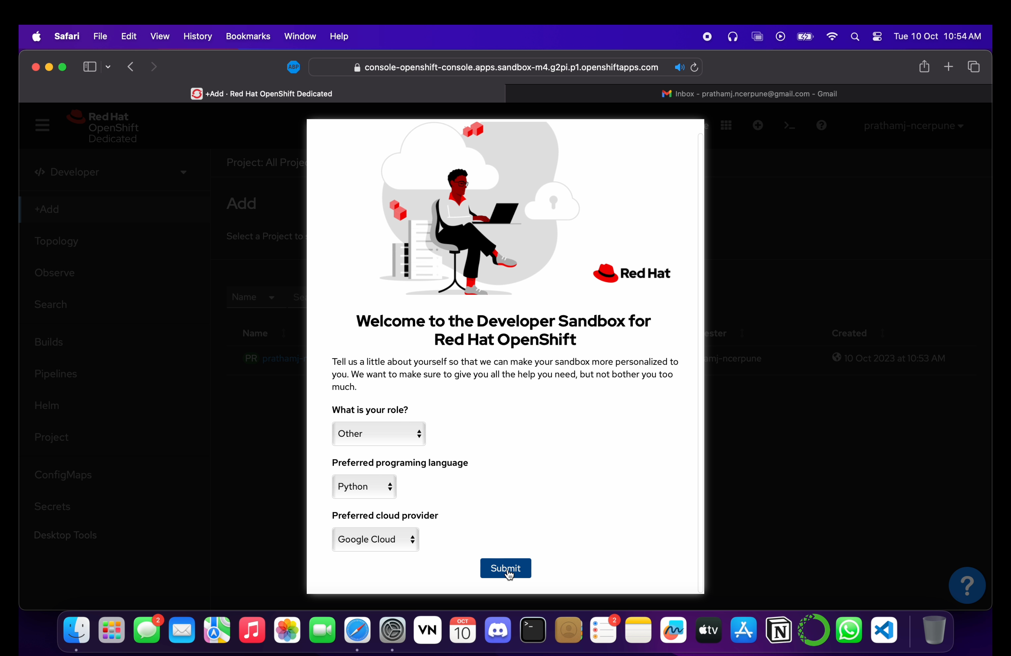

**Step 3: Code Development**

- Develop or import the website/application code into the Codenvy workspace.

- Ensure the code is functional and works within the Codenvy environment 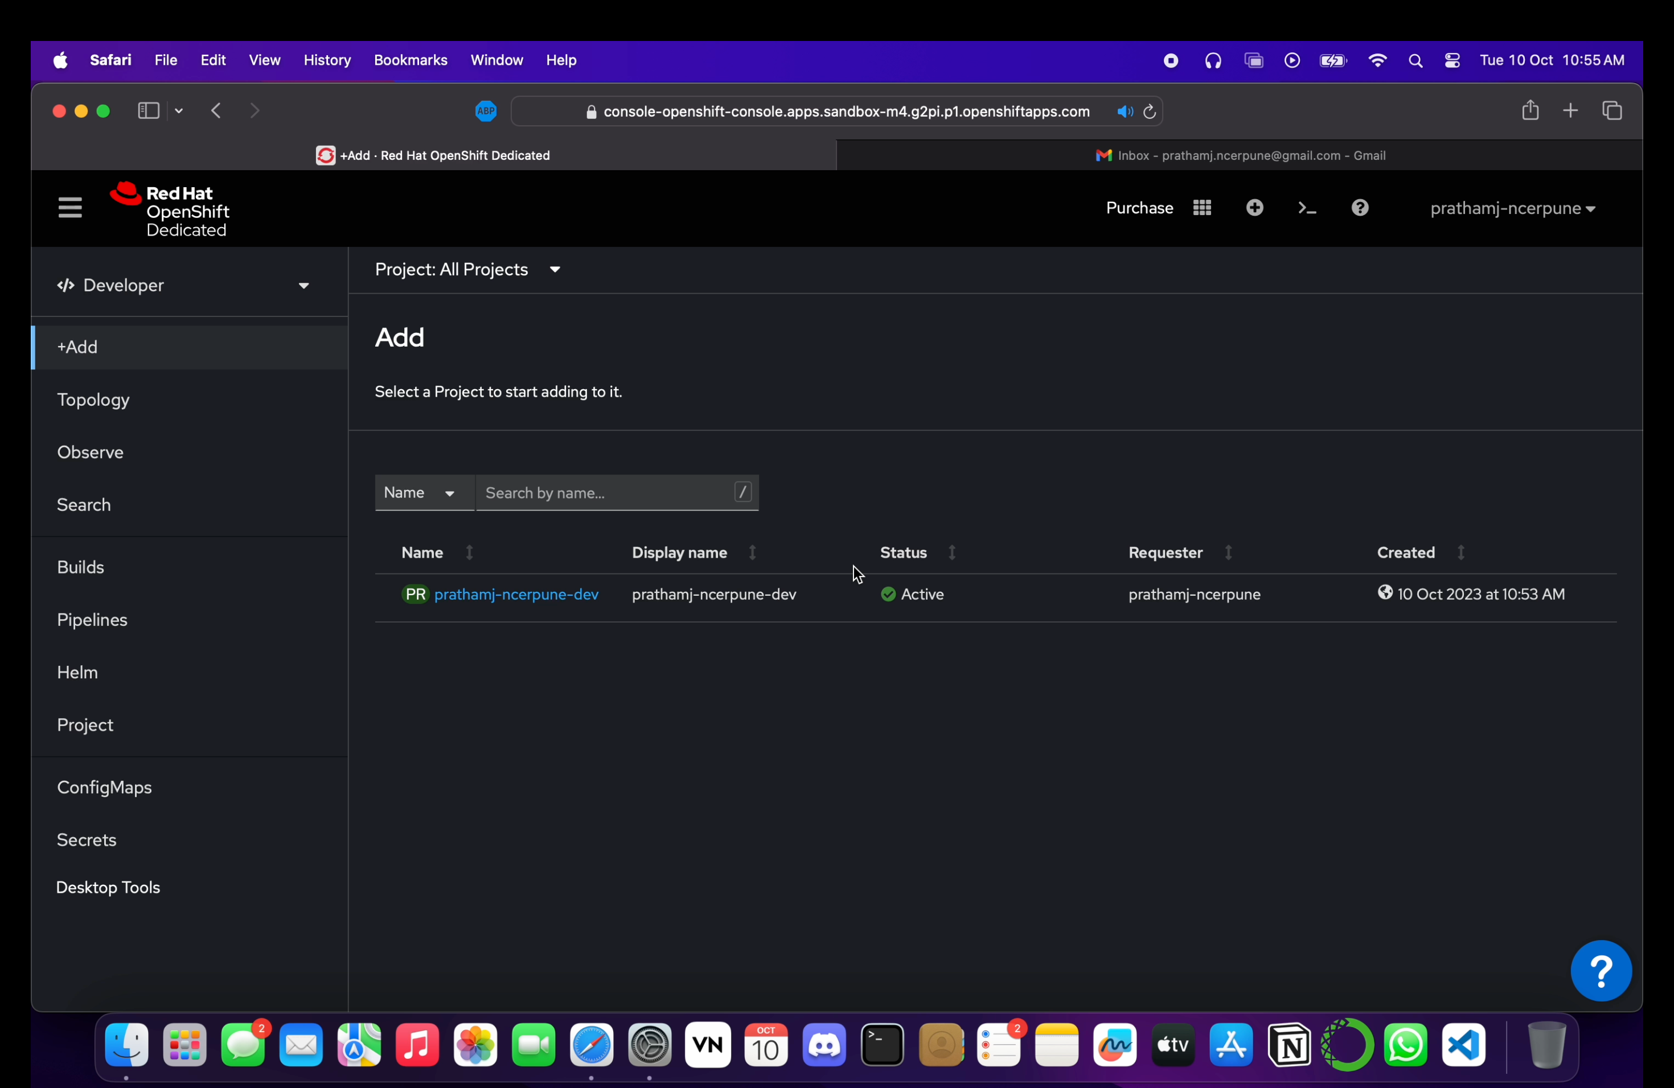

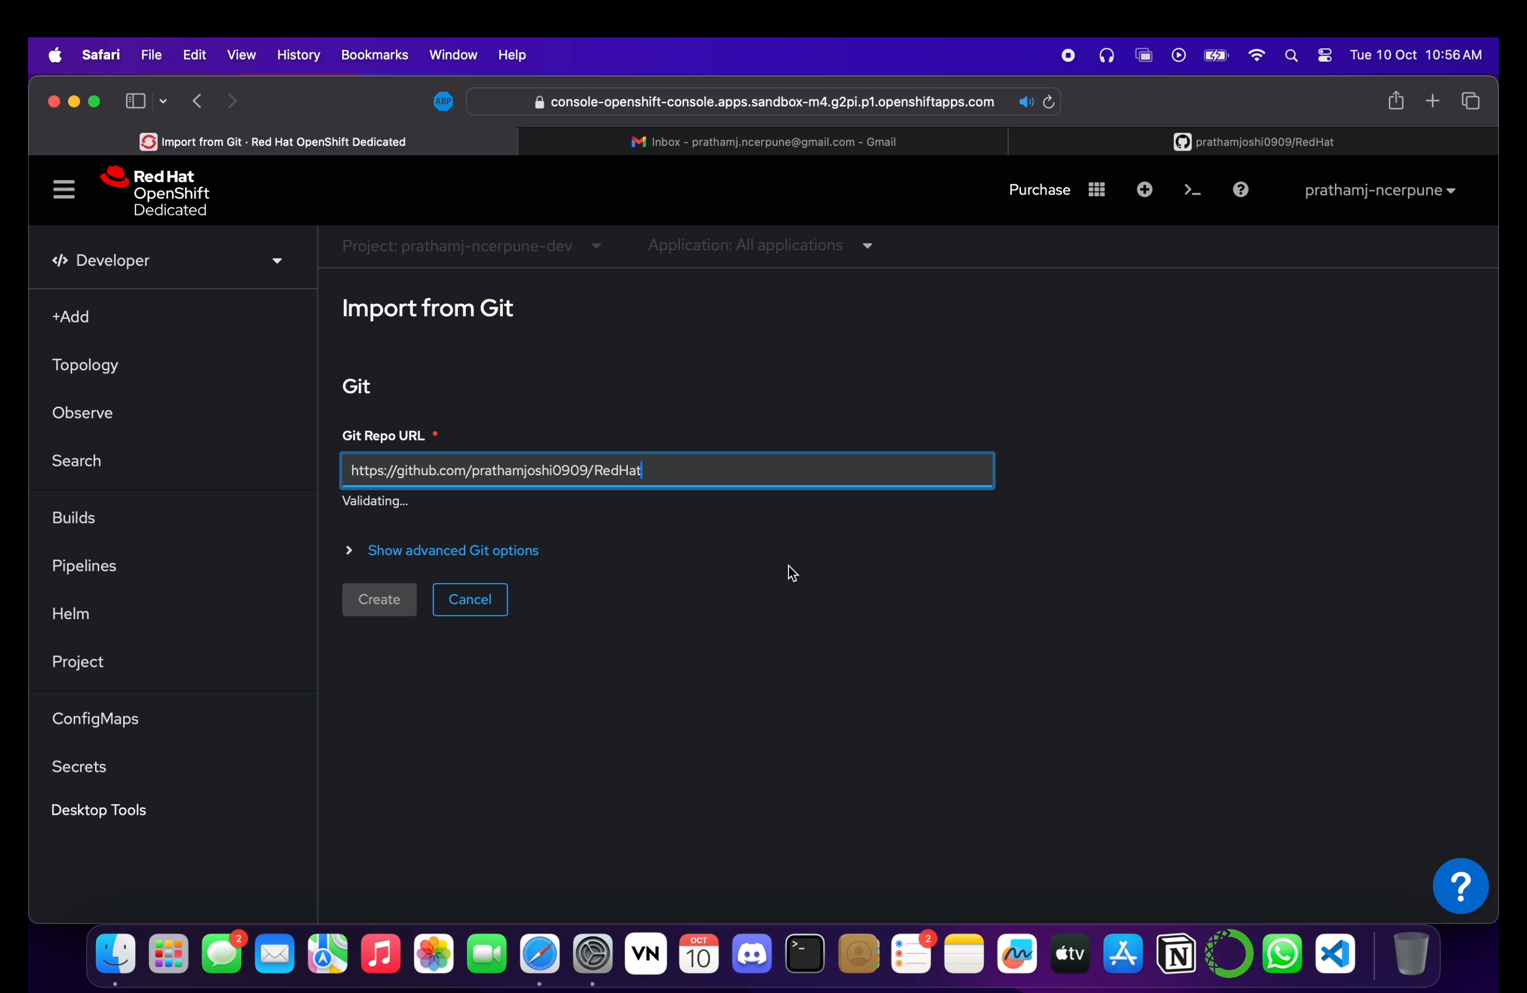

**Step 4: Containerization (Optional)**

- Dockerize the application if not already containerized.

- Create a Dockerfile within the Codenvy workspace and build the Docker image if needed.

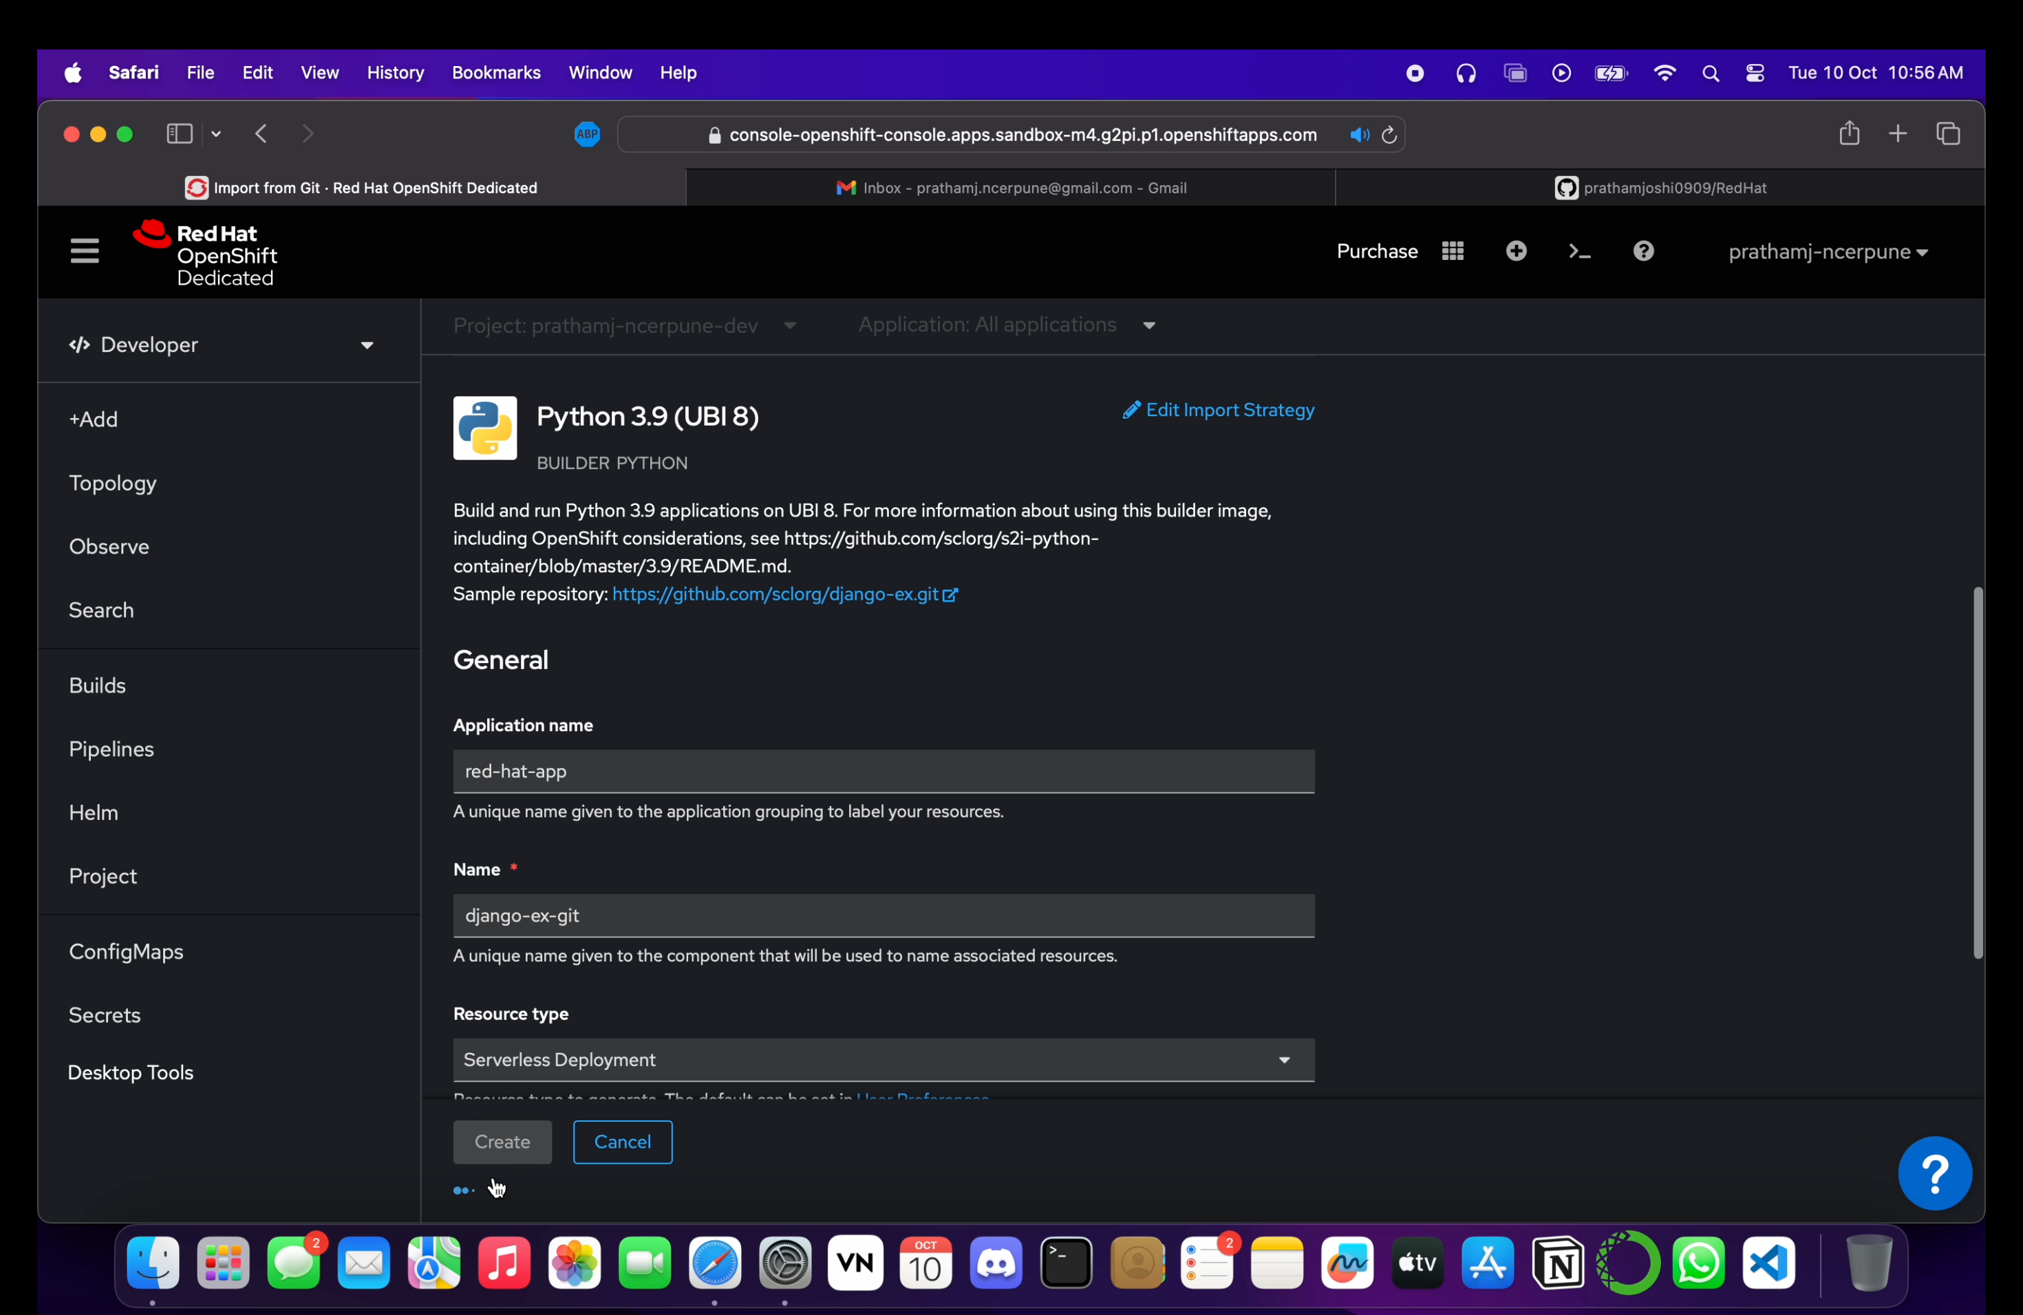

**Step 5: Deployment**

- Deploy the website/application within the Codenvy workspace.

- Verify the successful deployment and functionality of the website.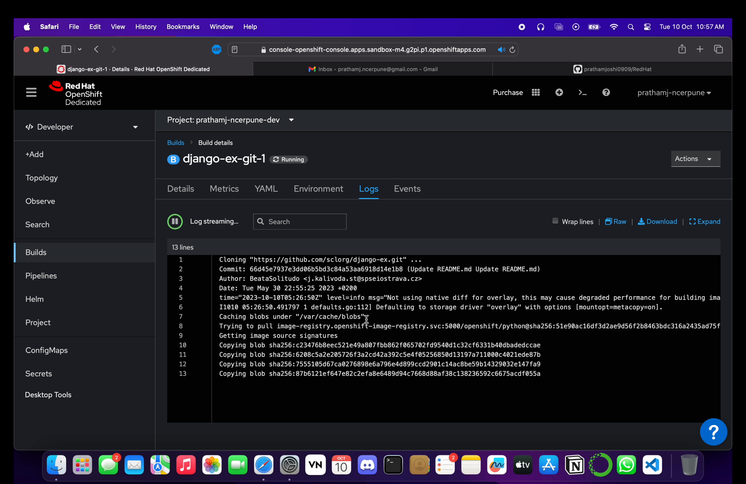

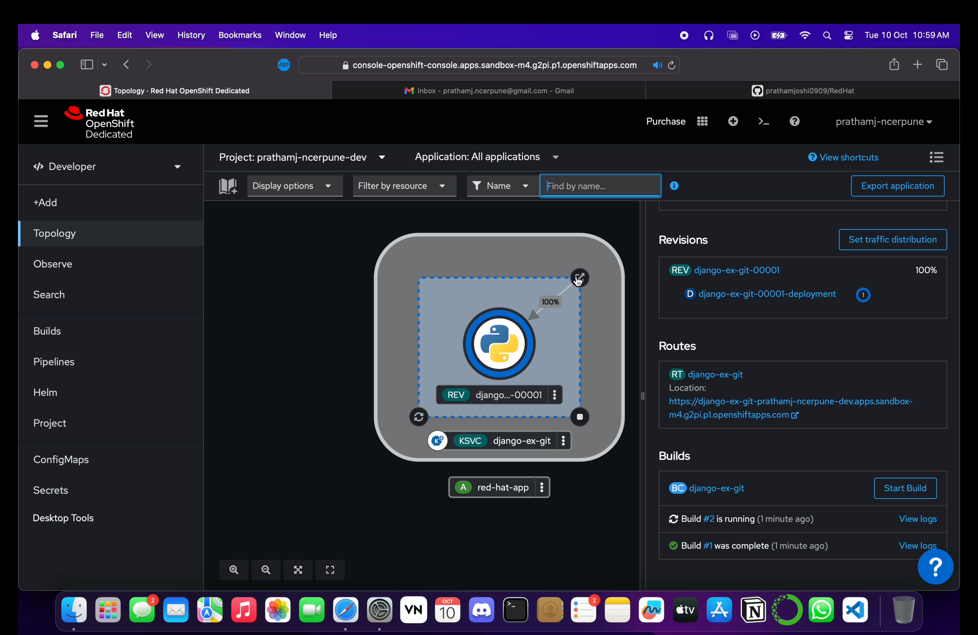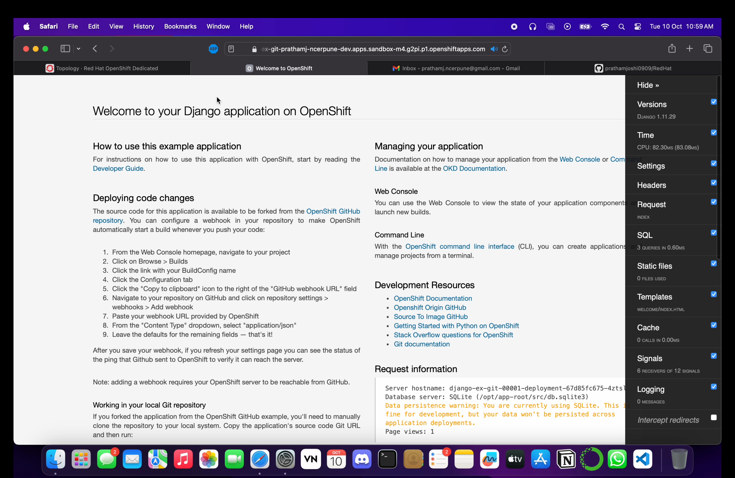 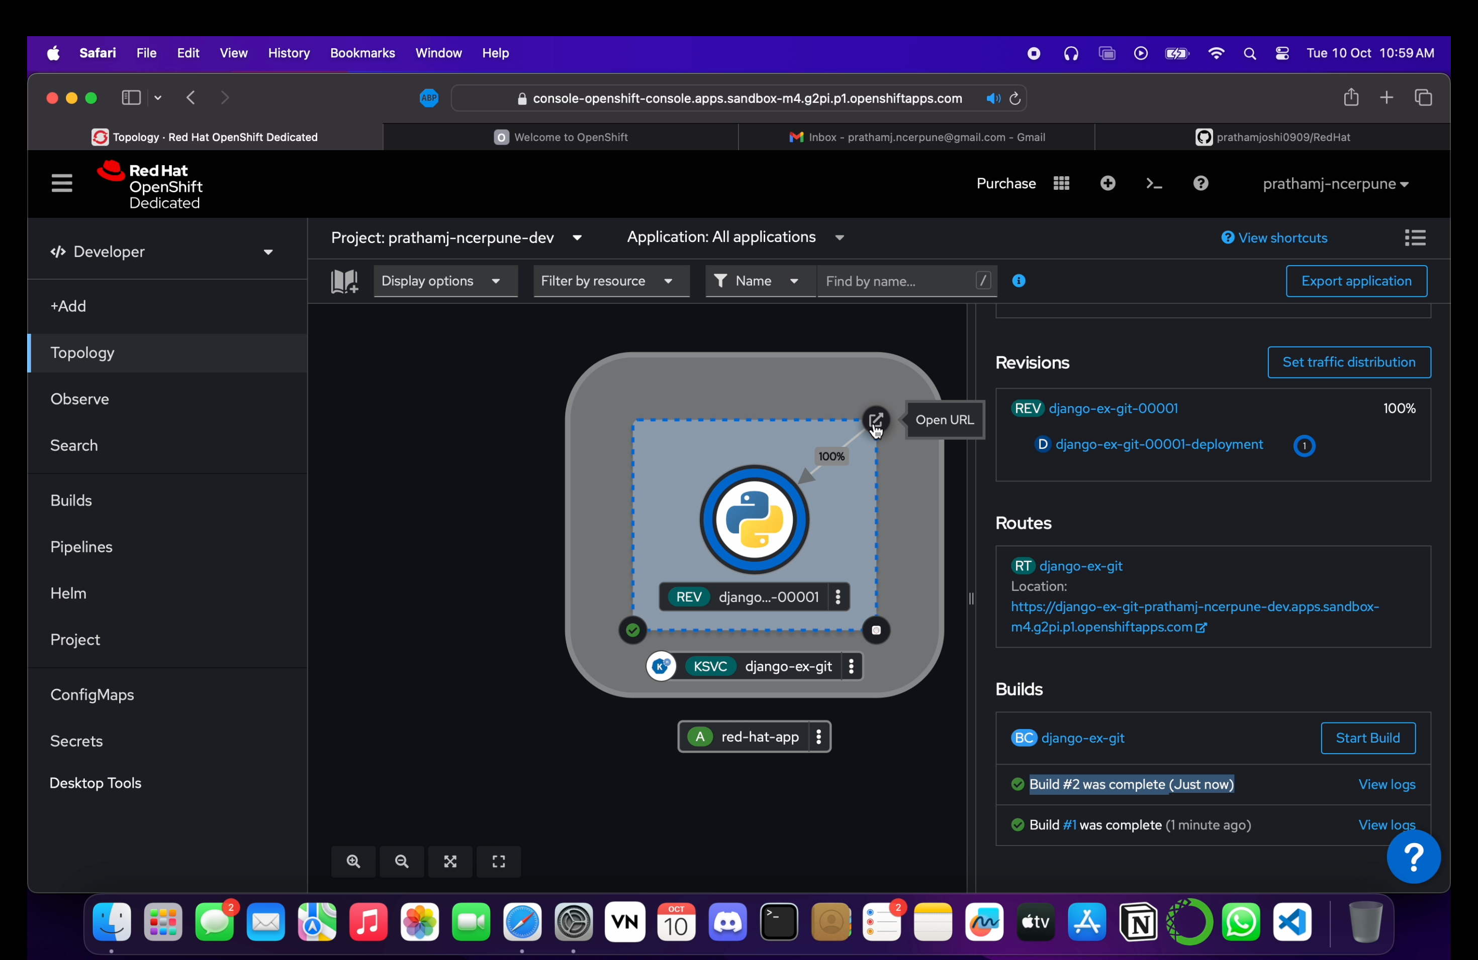

**Conclusion:**

Successfully demonstrated the provisioning and scaling of a website using Codenvy. This experiment highlighted the process of setting up a development environment, deploying a website, and dynamically adjusting resources to accommodate varying loads, ensuring efficient performance under different conditions.